Woodside Elementary School Expectations
 | BE SAFE | BE RESPONSIBLE | BE RESPECTFUL
CLASSROOM  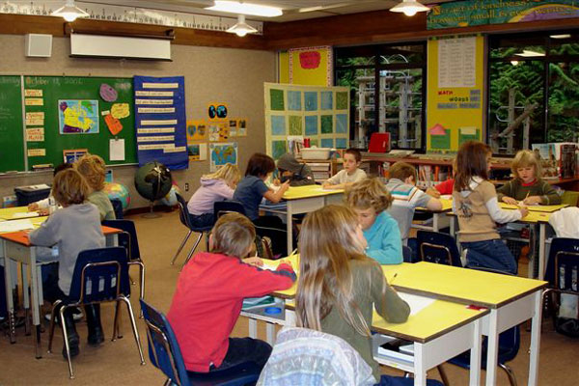 | - Keep hands and feet to self  - Sit properly at desk  - Listen and follow all directions | - Active listening  - Arrive to school on time  - Participate  - Pick up after yourself  - Be on task (focus)  - Try your best | - Take turns  - Share supplies  - Use manner words like “please” and “thank you”  - Help others
HALLWAY  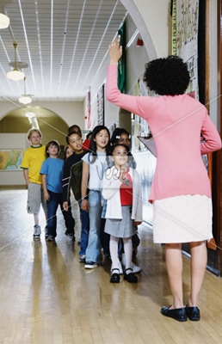 | - Walk to the right  - Keep hands and feet to self | - Walk quietly  - Get to the right place quickly  - Use whisper voices if necessary | - Listen to adults’ directions  - Walk silently
BATHROOM  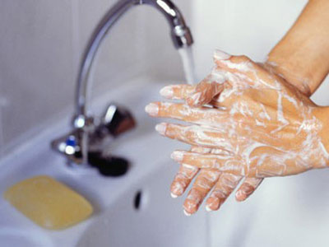 | - Keep feet on floor  - Wash hands with 1 squirt of soap  and water  - Put towels in trash can | - Keep visits short and go right  back to classroom  - Flush toilet  - Report problems | - Give people privacy  - Use quiet voices
CAFETERIA  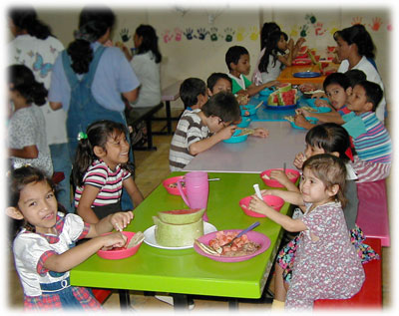 | - Keep hand and feet to self  - Walk carefully  - Sit in seat until asked to move  - Look for the quiet signal | - Follow adults’ directions  - Clean your space  - Take care of your belongings  - Raise your hand for help  - Raise hand if ready to clear | - Talk quietly  - Say “please” and “thank you”  - Remember personal space  - Use inside voices  - Use appropriate language
PLAYGROUND  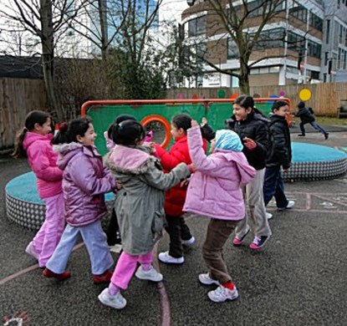 | - Play by the rules  - Use equipment properly  - Keep hands and feet to self | - Stay in assigned area  - Wear appropriate clothing | - Obey rules and take turns  - Play fair and share  - Show good sportsmanship
BUS  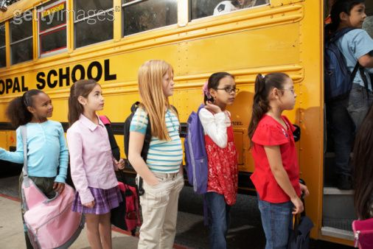 | - Use inside voices  - Keep hands and feet to self  - Walk in one line  - Tie shoelaces (ask for help if needed) | - Keep your place in line(don’t cut)  - Be a helper when asked | - Use quiet voices  - Follow adults’ directions
ASSEMBLY  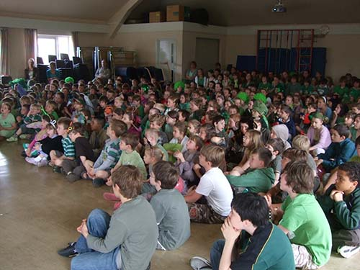 | - Sit on your bottom.  - Hands in lap. | - Use silent fingers  - Listen to adults the first time. | - Look at the speaker  - Be polite to others  - Listen quietly  - Clap for performers

October 8, 2010

